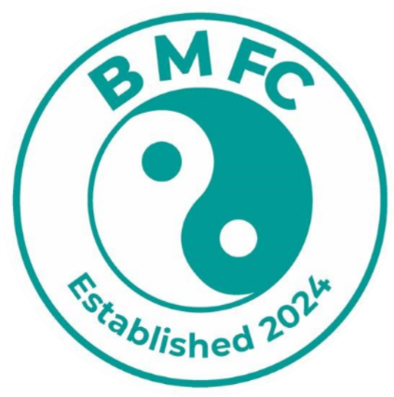

Balanced Minds FC Consent Form
This form will need to be completed either on a Laptop/PC or by hand. In order to complete this form, you will need to save a copy, complete the relevant fields and then re-save the form.
Please read this document in depth and ensure that all details are correct, and the relevant sections are completed before submitting. Once complete, please save or print this form, the form can then be handed to a member of the team at Balanced Minds FC or emailed to info@balancedmindsfc.com.
For Parents
Please ensure that you read the options in depth and select the options which apply to you. Please note that without your expressed consent, we are unable to include you in relation to the objectives set out below.
Please select the relevant option(s) below regarding consent in relation to you and/or your child if you are acting on behalf of your child.
☐ I give my full expressed consent to Balanced Minds FC to capture photographic images of myself and I also consent to these images being shared on the Club’s website and social media channels namely, X (previously Twitter), Facebook, TikTok, Instagram and YouTube.
☐ I give my full expressed consent to Balanced Minds FC to capture video images of myself and I also consent to these images being shared on the Club’s website and social media channels namely, X (previously Twitter), Facebook, TikTok, Instagram and YouTube.
For Parents on behalf of their children
Please ensure that you read the options in depth and select the options which apply to you and\or your child. Please note that without your expressed consent, we are unable to include you in relation to the objectives set out below.
Please select the relevant option(s) below regarding consent in relation to you and/or your child if you are acting on behalf of your child.
☐ I give my full expressed consent to Balanced Minds FC to capture photographic images of my child and I also consent to these images being shared on the Club’s website and social media channels namely, X (previously Twitter), Facebook, TikTok, Instagram and YouTube.
☐ I give my full expressed consent to Balanced Minds FC to capture video images of my child and I also consent to these images being shared on the Club’s website and social media channels namely, X (previously Twitter), Facebook, TikTok, Instagram and YouTube.
Advertisement/Sponsorship of Balanced Minds FC
Please ensure that you read the options in depth and select the options which apply to you and/or your child. Please note that without your expressed consent, we are unable to include you in relation to the objectives set out below, which may have further implications when advertising your business as a sponsor of the club.
☐ I give my full expressed consent to Balanced Minds FC to capture photographic images of my child and I also consent to these images being shared on the Club’s website and social media channels namely, X (previously Twitter), Facebook, TikTok, Instagram and YouTube in line with the sponsorship of Balanced Minds FC.
☐ I give my full expressed consent to Balanced Minds FC to capture video images of my child and I also consent to these images being shared on the Club’s website and social media channels namely, X (previously Twitter), Facebook, TikTok, Instagram and YouTube in line with the sponsorship of Balanced Minds FC.
For Coaches
Please ensure that you read the options in depth and select the options which apply to you and\or your child. Please note that without your expressed consent, we are unable to include you in relation to the objectives set out below.
☐ I give my full expressed consent to Balanced Minds FC to capture photographic images of myself and I also consent to these images being shared on the Club’s website and social media channels namely, X (previously Twitter), Facebook, TikTok, Instagram and YouTube.
☐ I give my full expressed consent to Balanced Minds FC to capture video images of my child and I also consent to these images being shared on the Club’s website and social media channels namely, X (previously Twitter), Facebook, TikTok, Instagram and YouTube.
Your Details
Please provide us with your details in the table below.
First Name | Click or tap here to enter text.
Surname | Click or tap here to enter text.
Postal Address | Click or tap here to enter text.
Email Address | Click or tap here to enter text.
Contact Telephone Number | Click or tap here to enter text.
Your Child’s Details
Please provide us with your child’s details in the table below, if you are providing consent on their behalf.
First Name | Click or tap here to enter text.
Surname | Click or tap here to enter text.
Postal Address | Click or tap here to enter text.
Age Group | Click or tap here to enter text.
Withdrawal of Consent
Should you wish to withdraw your consent at any time, you can do so by submitting an email to info@balancedmindsfc.com advising that you wish to withdraw your consent – which is your right. However, please note that if this is in relation to advertisement/sponsorship of the club then this may have further implications of us being able to advertise your business or sponsorship of the club.
☐ Please tick this box to signify you have read the form in its entirety and that this form has been completed by you.
Please print your name below in CAPTIAL letters, sign and date the form.
Full Name: Click or tap here to enter text.
Date: Click or tap to enter a date.
Signature:
Please return this form via info@balancedmindsfc.com.

Further information on how we collect, process and store your information can be found in our Privacy Policy available on our website – https://www.balancedmindsfc.com/home

