Foods to Balance Blood Sugar
Balanced blood sugar levels are crucial to a healthy and prosperous life. Balanced blood sugar levels prevent disruption of your body’s functions and help your overall health. Here are a few foods to add to your diet to help balance your blood sugar:
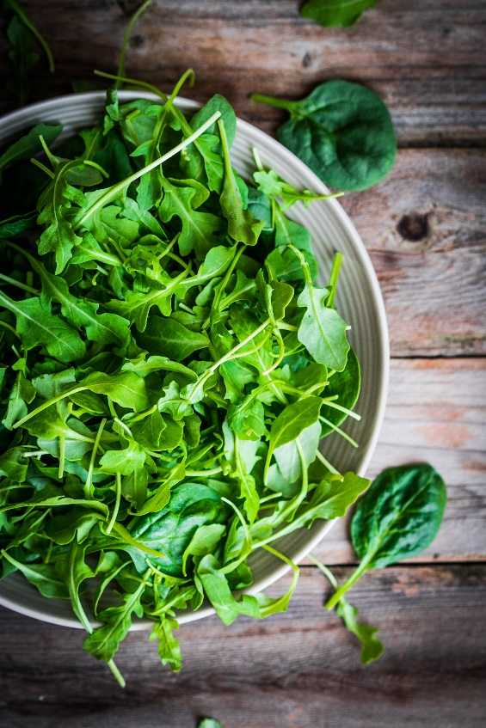
- Greens:
You can never eat too many greens. For the best blood sugar benefits, go for nutrient-dense, low-carb greens like spinach, kale, and broccoli. These greens are also very rich in protein and calcium, which help your body in multiple areas. You can toss these greens in salads with olive oil and chunks of salmon. Studies have shown that these three vegetables contribute to dramatic improvement in patients who are constantly battling with their blood sugar.
- Low fructose fruits:
Fruit is always a must, but for blood sugar-specific management, choose fruits that are low fructose, such as cantaloupe, raspberries, blueberries, kiwi, and blackberries. You can snack on them throughout the day, or toss them in your salad, smoothies, or acai bowls.

- Protein:
Protein is essential for slowing down glucose absorption in your body, which helps regulate your blood sugar levels. Add foods to your diet that are packed with protein, like wild salmon and other types of fish, beef and other types of lean meat, cottage cheese, Greek yogurt, and eggs. Make your diet interesting; try snack ideas like celery sticks dipped in all-natural peanut butter. This snack is rich in protein and only contains the good kind of fat. Remember everything in moderation, however. Too much protein actually can become sugar in your blood, creating a condition called gluconeogenesis; 40 to 70 grams of protein is enough for a day.

- Herbs and Spices:
Herbs and spices are natural supplements for balancing your blood sugar levels. They not only add flavor to your dishes but they may also help your hormone’s lower your blood sugar. Some spices, like turmeric, contain anti-inflammatory properties, which help in balancing out your sugar.

- Low-calorie drinks:
Cut out sugary, high-calorie drinks from your diet. Add drinks like cinnamon tea, lemon water, and cucumber juice in your daily routine.

- Whole grain foods:
Whole grain foods that are also rich in protein, like millet and quinoa, provide and store energy without causing spikes in your blood sugar levels.

- Beans:
Beans are a good source of protein, low carb, and rich in fiber, all important factors in balancing your blood sugar. Hummus, lentils and garbanzo beans are good examples and great dietary choices. Remember to soak them the night before to promote easier digestion.

- Nuts:
Nuts like almonds and walnuts contain healthy amounts of fiber, protein, and healthy fats, and are a low carb snack idea.
Try balancing your blood sugar the natural way by changing the way you eat. You’ll be amazed at the difference!

If you would like to learn more about my [insert link for your CTA (call to action)], just click here.
Yours in health and wellness,
Health Coach Name

