
PRESS KIT

September 2022
Holt Energy Advisors Ltd
Holt Energy Advisors Ltd (“HEA”) is an energy advisory company delivering expert commercial, legal and transaction advisory solutions to the energy sector. HEA was formed in 2018 and provides the following services:
- Acquisition and Divestments Advisory
- Due Diligence
- Commercial & Legal Advisory
- Economic Analysis
- Hydrocarbon Sales and Marketing
- Energy Procurement
- Strategy Consulting
- Training
Based from its offices in Canary Wharf , London and ABZ Business Park in Aberdeen, the HEA team provides services to listed and unlisted corporate clients, national governments, joint venture groups, banks and other advisors as well as industry trade groups globally.
The HEA team have collective experience of over 40 completed transactions in the energy sector valued at over $5.5 billion covering 20 countries globally with due diligence projects completed in a further 28 countries.

Our Address: 202 Davenport House, 16 Pepper Street, London, E14 9RP.
Telephone: + 44 (0) 203 916 0101
General Email: enquiries@holtenergyadvisors.com
Media Enquiries: media@holtenergyadvisors.com

Logo and Colour Palette
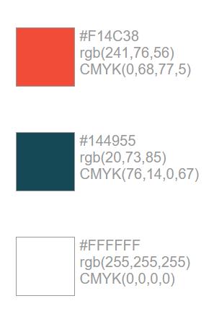
Cropped Logo (Large)



Stacked (Preferred Format)


Abbreviation
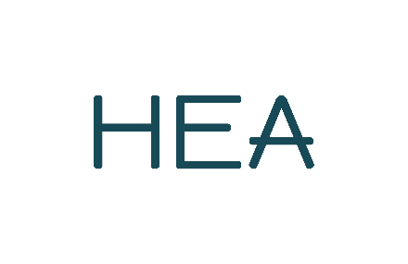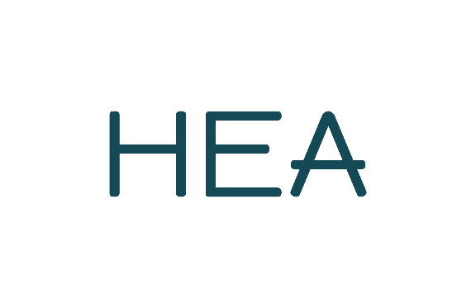
Inverted Images



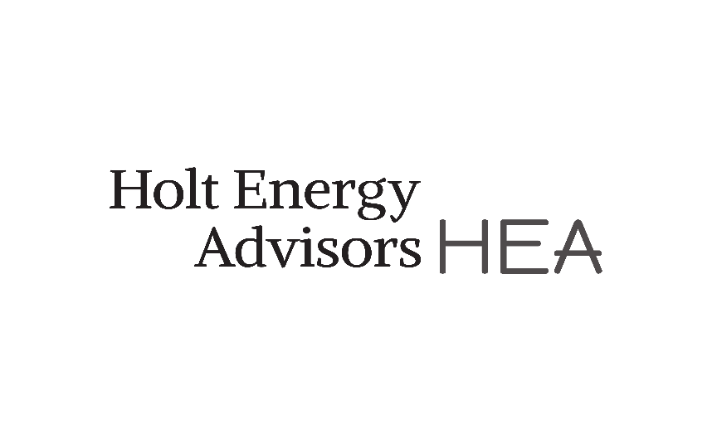
Logo / Image Download Link

https://ws.onehub.com/folders/1thcmw11

London Office Images



Managing Director Images


