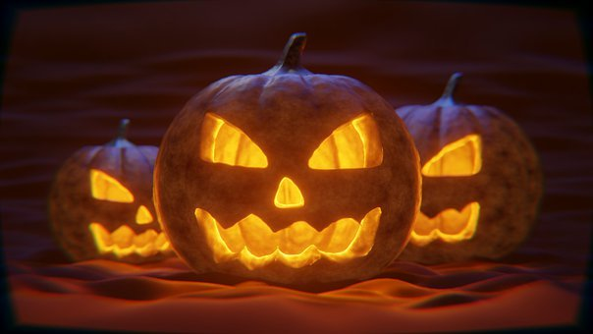

What is Halloween and why do we celebrate it

Halloween derives from “All Hallows Eve” the night before the two Christian holy days, “All Saints Eve” and “All Souls Day”. Known as “ Allhallowtide”, these three days are an opportunity to celebrate the saints and wish the recently deceased a safe journey to heaven.

Although the meaning of Halloween is actually down to religion, there is no direct mention of it in the bible. It is more a western tradition, originating from an ancient Celtic festival of “Samhain”. During this celebration people would create spectacular, eerie and spooky garments to ward off ghosts. It is written that Pope Boniface IV originally set 13th May to be the celebration for the Blessed Virgin Mary but it is believed to have been moved by Pope Gregory III to celebrate all the saints, labelling it as “All Saints Day”. At the time, the day before “All Saints Day” was called “All Hallows Eve”later to be branded Halloween which has become the iconic day we know and love (or hate) today.

A Fine Line

You either love Halloween or you hate it, if you hate it there are many reasons why you might. It could be the terrifying ghouls, ghosts or monsters lurking in the darkness or maybe it is the scary children in costumes who arrive at our door asking for sweets. For many it is a time to celebrate, have fun and play childish pranks. For others, it is a long standing tradition to be celebrated. There is a fine line between the two and whatever your reason for honouring Halloween, it is a question of taste. Do you recognise it for its true meaning or just relish the thought of all the things that go “bump in the night”?.

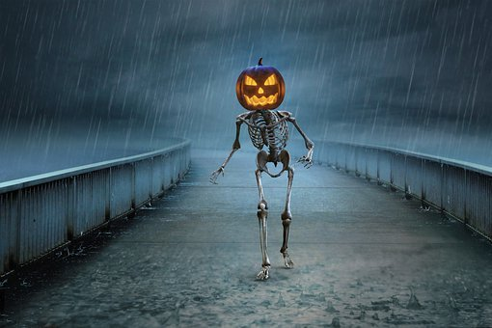

Skeletons in the Closet

We all know that people have secrets and sometimes these mysteries can be taken to the grave. There are things we have done in life that we are ashamed of, things that maybe just you and/or another know. It is fine to keep secrets about our past that bear no significance to the life we lead today, however what if those skeletons are more recent? What if those skeletons reveal something about someone that should be out in the open? What if something reveals the relationship we have proves the person you love is not really who you thought they were?

Face your Fears

We know confronting things head on is not easy, but we stand by the fact that everyone deserves the truth. You may not want to hear that your partner has cheated, nor that someone close to you has betrayed you. It may not be an infidelity problem. It could be a friend or family member has stolen from you. What if you are the black sheep of the family and know you have not done what you are being accused of?.

Halloween Special Offer

At Lie Detector Services LTD, we want to help you to face your fears and provide you with the tools to do just that!. We offer lie detection services in confidential, secure and discreet office locations all over the UK and even at your home, if this is what you prefer. Contact us today and free yourself from the demons that have been troubling you for so long. Our dedicated Costumer Support Team will be happy to walk you through the process and help you find the answers you so desperately deserve.

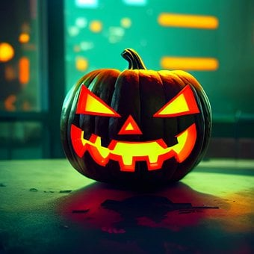

Trick or Treat

We believe our clients should not be deceived by their accuser and we know an honest person should have the tools to show their innocence. With that in mind, we are offering a 10% discount on all bookings made and paid in full by Monday 31st October for anyone that mentions HALLOWEEN10 when they contact us.

Shake off the cobwebs and contact us today or book online, let us help you come out of the shadows and move into the honest light you so rightfully deserve.

