Your Pilgrimage (YP)
Medical Escalation Policy

Document Number:
Version: | 0.1
Approved by:
Date approved:
Name of originator/ author:
Date Issued: | March 2016
Last Review Date:
Next Review Date::
Target audience: | YP Clinical Staff and Leadership Teams
Replaces:

Contents
Introduction 2
Scope and Duties 2
Policy Review 2
Related Policies 2
Medical Escalation Procedure 3
YP Escalation Plan for Outbreak of D&V 4

Introduction
This document brings together YP clinical escalation procedures under one policy.

Scope and Duties
All YP clinical escalation procedures will be included in this policy. Currently there are two such procedures. These are the medical escalation procedure and the infection outbreak escalation procedure (referenced also in the Infection Prevention and Control Policy).
The Pilgrimage Director will take advice from the Medical Leadership Team (MLT) about any clinical procedures that need to be incorporated under this document.
The formation of appropriate All YP clinical staff should be familiar with this policy and its component procedures.
Leadership teams should be aware of the procedures included in this policy and their roles as appropriate within these procedures.

Policy Review
This policy will be reviewed annually. Earlier review may be required in response to exceptional circumstances, organisational change or relevant changes in legislation or guidance.

Related Policies

YP Infection Prevention and Control Policy
YP Isolation Policy

Medical Escalation Procedure
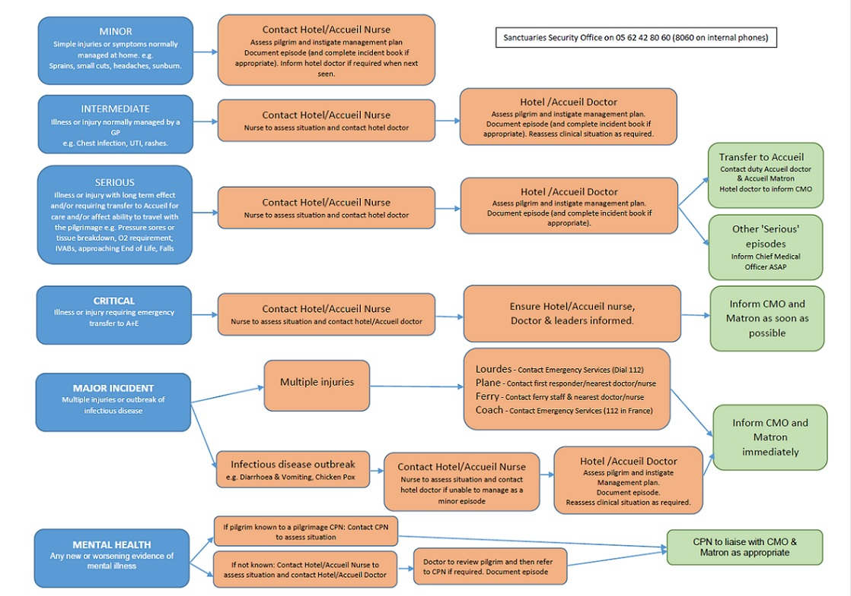

YP Escalation Plan for Outbreak of D&V
 | Situation | Actions
Green | Normal.  No cases D&V on pilgrimage or in other groups within any YP hotels. | No specific action required.  Stress hand hygiene and encourage early reporting of problems.
Amber | Episode compatible with either infectious or dietary cause.  2 cases mild diarrhoea up to type 5 stool, or single case 6/7 stool plus or minus vomiting. | Isolate individuals for 48 hours  Consider protecting pilgrims to infection – immunosuppression or active cancer.  Inform clinical leadership team.
Red | Evidence risk of person to person transmission.  More than two cases of diarrhoea and vomiting, multiple cases of diarrhoea, multiple onset times suggestive of transmission person to person. | Cohort cases, curtail extra socialising out of hours for this hotel.  Consider need to move vulnerable to different hotel.  Consider reduction of contact e.g. sign of peace.
Black | Evidence risk of spread within pilgrimage as a whole.  Two or more hotels affected, more than 10% of any single hotel group affected. | Quarantine hotel group(s).  Increase support for hotel nursing staff.  Isolate vulnerable pilgrims.  Notify Bureau/PHL.
vs 1.0

