FULL MOUTH RECONSTRUCTION

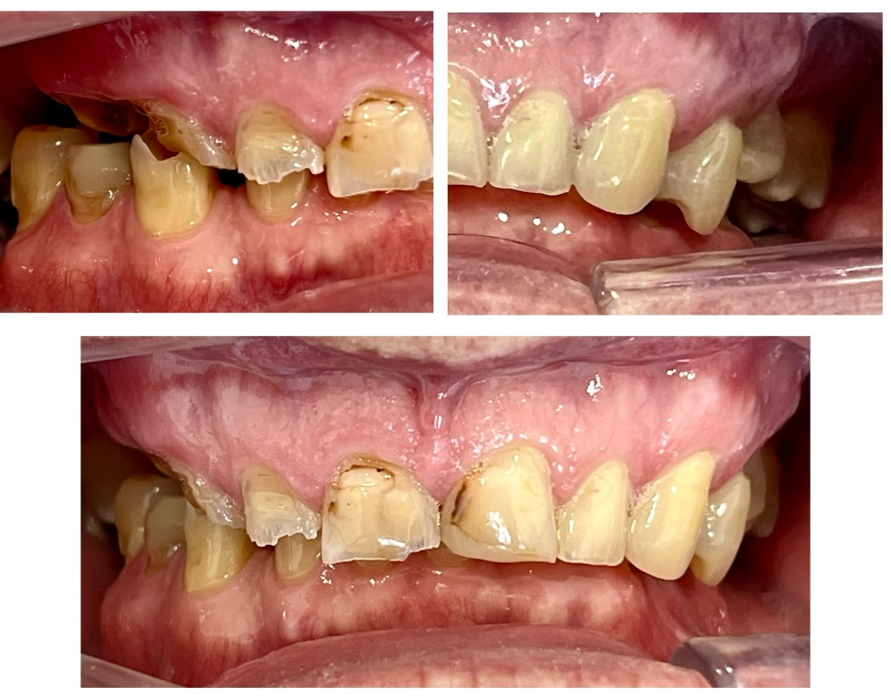
BFORE vs AFTER

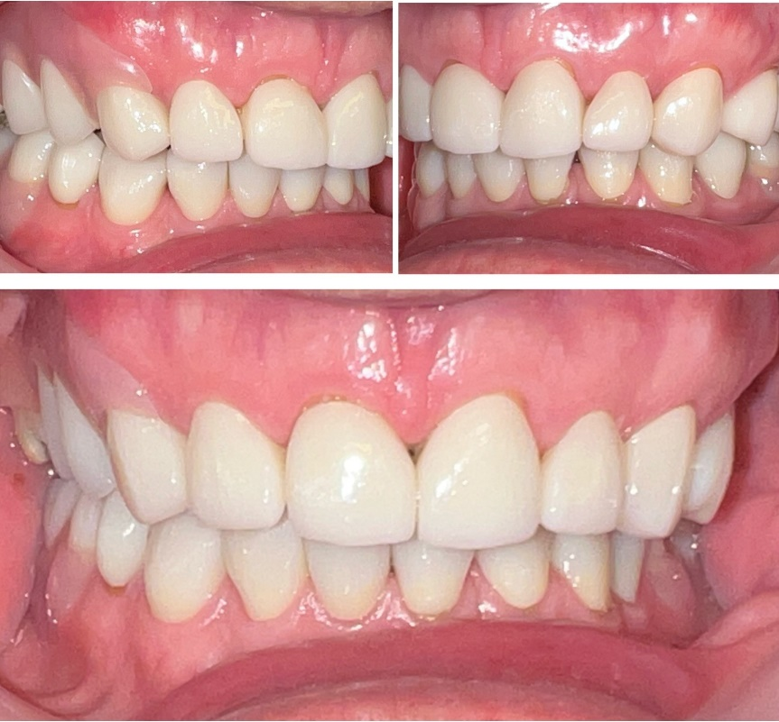
vs

