`

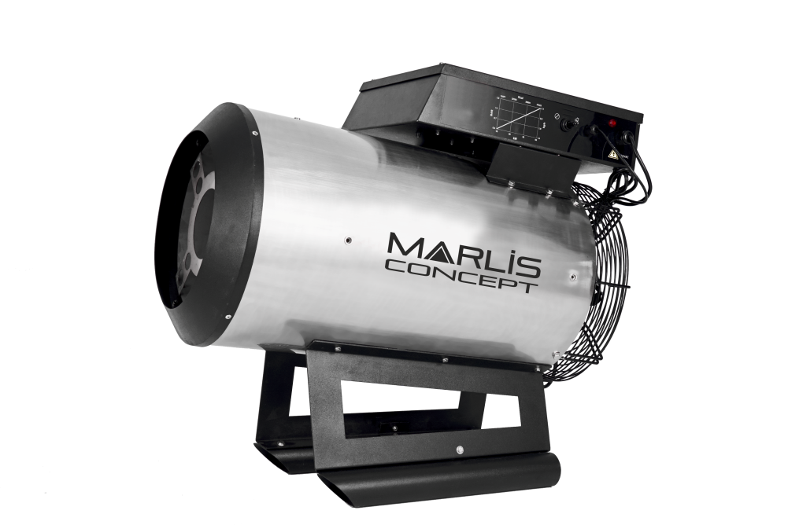
OWNER’S MANUAL

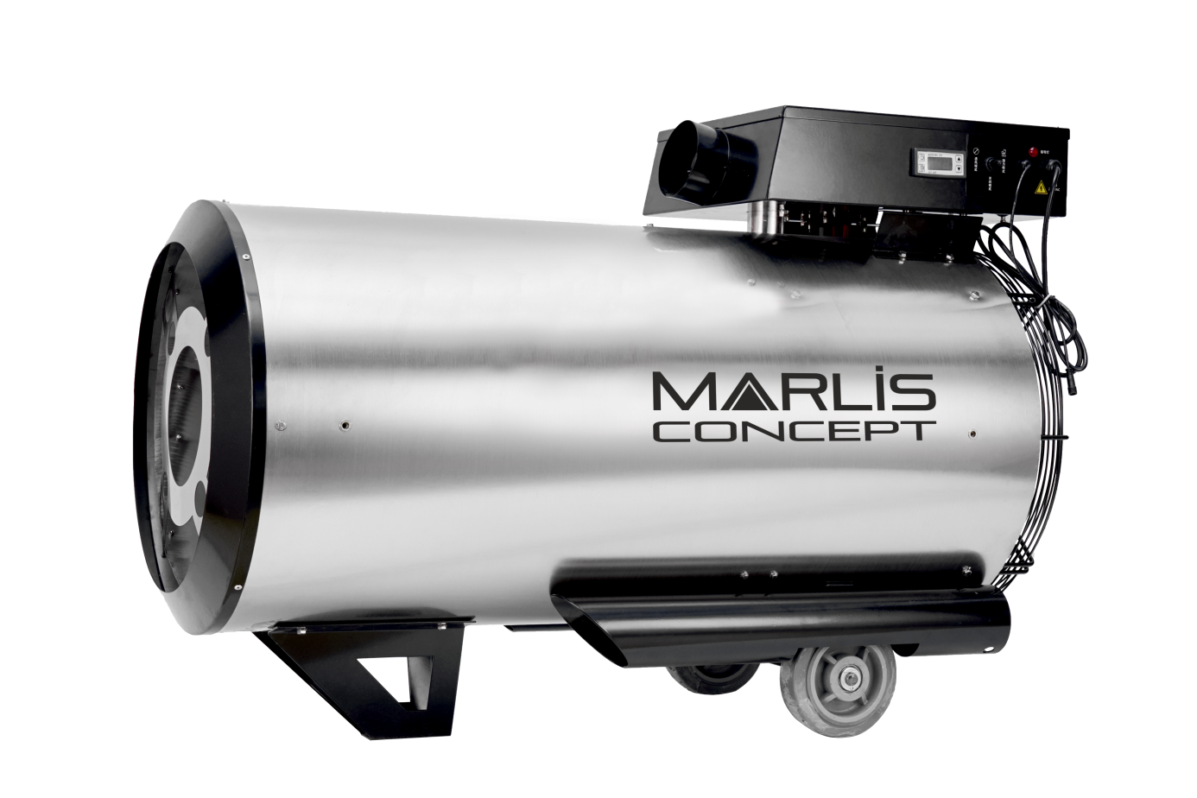
ZONDA
CAUTION
For your own safety, please notice the warning sign and read the operation manual carefully before you operate the machine.
The device must be installed in accordance with the rules in force.

CONTENTS

I - DESCRIPTION AND OPERATION 4
II – INSTALLATION AND USE 5
III – AFTER USE 5
IV – MAINTENANCE - SERVICING 6
V – FAULT FINDING 7
VI – TECHNICAL CHARACTERISTICS 9
VII – GAS PRESSURE / POWER SETTINGS 9
VII.1 ZONDA 45 : 9
VII.2 ZONDA 60 : 10
VII.3 ZONDA 90 : 10
VII.4 ZONDA 130 : 10
VIII – ELECTRICAL DIAGRAM FOR ZONDA 60/90/130 11

Read these instructions carefully
FOR YOUR SAFETY |  | FOR YOUR SAFETY
If you smell gas:  - Open windows  - Don’t touch electrical switches  - Extinguish any open flames  - Immediately call your gas supplier |  | Don’t store or use gasoline or any flammable vapors and liquids in the vicinity of this or any other appliance.

The life of this heater and its efficiency will be optimal if its use and maintenance is carried out according to the current norms and instructions.
Before installing the heater, verify that the local gas distribution (type of gas, pressure, regulator, etc.) is compatible with the heater requirements.
The installation, regulation and conversion to another gas, requires the intervention of an authorized technician.
MARLIS CONCEPT must be consulted before substituting parts not listed in this manual.

It is the responsibility of the installer to: check that the installations is in accordance with the following norms and give the user the current user’s manual

Information for the user:
- Any modifications to the heater or its installation, even the most minimum modification, change or elimination of security components or pieces that influence the efficiency or the proper combustion, will result in the loss of the certification and the voiding of MARLIS CONCEPT’s guarantee.
- It’s imperative to perform the cleaning and periodic maintenance.

MARLIS CONCEPT reserves the right to modify the current manual. Only the manual included with each heater can be considered as contractual.


ATTENTION: this heater should not be used in domestic buildings or in establishments for public use.

ATTENTION: it is necessary to add complementary ventilation depending on the model

I - DESCRIPTION AND OPERATION

I.1. Warnings:
- The purpose of this heater is the raising of farm animals and heating of agricultural use warehouses.
- For your own safety, please notice the warning sign and read the operation manual carefully before you operate the machine.
- Maintain this heater in accordance with these instructions.
- Keep this document near the heater.
- Follow the procedures described.
- Never lean on the heater.
- Ensure that any easily flammable material is kept at least 3 meters from the heater.
- Do not install the heater on a flammable floor.
- Ensure the presence of sufficient air for good combustion.
- Carry out repair and maintenance work only if the appliance has cooled down sufficiently and after unplugging it.
- Make sure you have a fire extinguisher nearby.
- The gas connection must comply with regulations in force.
- Gas cylinders must only be used in a vertical position.
- Do not place gas bottles in a stream of hot air.

I.2. Operating:
When the switch is in position « HEATING » and a heating command is launched: the fan start.
After 10 seconds the gas valve opens the gas supply to the burner. The gas is mixed with air at the burner inlet. This mixture is ignited by an electric spark. This spark stops automatically as soon as the flame is good. The hot air, obtained by combustion, is then blown into the building. When the switch is in position « OFF » or a stop command is asked: the heating stop. By switching to the position « FAN ONLY », the heater can be used as fan.

I.3. Security:
- The heater is equipped with a burner relay that automatically controls ignition and gas supply. The burner relay also controls the flame as long as the heater is operating. In the event of a fault, the burner relay automatically stops heating and the control panel indicator light begins to flash.
- The heater is equipped with an overheat thermostat which will cut off the gas supply if the unit overheats. Press the overheat thermostat reset button once the heater has cooled. Turn off the power and turn it back on to restart the device (this is how to reset the control box).
- Loss of flame is detected by the ionization probe and the gas electrical valves are immediately closed, this stops the burner and sets it in security mode. During this step the heater tries to start again 3 times. If it doesn’t succeed to start again, the heater stops totally and a security light on the body of the heater indicate this.
- Thermal protection of the heater is assured by an overheating thermostat.
- Ventilation fan operation is controlled by 1 air flow switch.
Restart after security stop needs a manual reset.

II – INSTALLATION AND USE

The heater must be mounted horizontally. For the installation, take into account the minimum distances to different walls.
Hang the heater on the hanging rings.
The heater must be connected to the gas bottle or gas tank in accordance with the rules in force.
If the heater must be controlled by an external thermostat or a controller, connect it to the thermostat socket provided (dry contact between terminals 2 and 3).
For ZONDA 60-90 and 130 it is strongly recommended to supply clean combustion air using a duct with a diameter of 100 and a maximum length of 6 meters. This duct must be connected to the outside air intake on the top of the heater provided for this purpose.
Insert the other side of the duct at the level of the building wall penetration connection.

II.1. Heating mode:

1. Check that the supply voltage corresponds to the voltage indicated on the nameplate.
2. Check the assembly instructions (previous paragraph).
3. Connect the pressure regulator and the gas supply hose to the gas cylinder(s), PROPANE cylinder(s) with a minimum content of 35 kg or a tank. Check with your dealer for proper fitment.
4. Make sure the switch is in the “OFF” position and connect the power plug to a grounded outlet.
5. Slowly open the gas supply valve.
6. If the heater is equipped with a thermostat or a clock, adjust them to the connection points provided.
7. The heating works by switching to the “HEATING” position.
8. Adjust the power according to demand using the diagram available on page 10.

II.2. Fan mode:

1. Check that the supply voltage corresponds to the voltage indicated on the nameplate.
2. Make sure the switch is in the “OFF” position and connect the plug to a grounded outlet.
3. By switching to the “FAN ONLY” position, the device can be used as a fan.

III – AFTER USE

1. Turn off the gas supply.
2. Leave the appliance running as long as there is gas in the pipe.
3. Switch to 0FF position. Remove the plug.

IV – MAINTENANCE - SERVICING

Turn off the gas supply, remove the plug and remove the thermostat plug when working on the heater. If the heater has just been operating, do not touch the outlet and the combustion chamber! Wait for them to cool before starting maintenance of the heater.

IV.1. General:

1. Keep the heater free of dirt and dust, clean with dry compressed air.
2. Have the heater inspected regularly by an authorized person (at least once a year, or more regularly in a dusty environment).
3. Check and clean the combustion air inlet port. The tube between the injector and the burner, as well as the burner and the injector, must be clean to ensure good combustion and maintain a blue flame. If the flame is yellow, consult your dealer.
4. Check and clean the intake grid.
5. Check that the fan is working properly and is not damaged, as well as its protective grid.
6. Check the wiring of the heater.
7. Ensure that the hose and gas installation are in good condition.

If the heater is stored for a long period, turn off the heater, turn off the gas supply, remove the plug, clean the heater and store it in a clean and dry place.
IV.2. Burner and probe:

1. Clean the burner head with a brush and compressed air
2. Adjust the probes (they are accessible through the blower mouth)
- for ZONDA 45: 3mm between the tip of the ignition probe and the burner
- for ZONDA 60, 90 and 130: 4mm between the tip of the ignition probe and the burner. The ionization probes are straight
3. The ignition and ionization probes can be cleaned using steel wool.

NOTE: When damage is caused by poor maintenance, the warranty does not apply.

V – FAULT FINDING

First check:
Check supply voltage.
Check gas supply.
Check that burner fault indicator is not lit.

If faults occur in the heater, the list below can be used to locate the problem.
Normally, faults are relatively easy to correct. Common faults are listed. The numbers indicate the possible cause as shown in the table. In the event of defects not mentioned or requiring repairs, contact an approved repairer. CAUTION: Unplug the mains when servicing or adjusting the appliance.

Defect Cause possible
The device doesn’t start 1-2-3-4-5-6
The heater is no longer heating (light on) 7-8-9-10-11-12-2-13-14
High gas consumption 15-16
The heater doesn’t turn off with the switch 5-17
Defect | Solution
1. No power supply | Check that the heater is well plugged in and that the outlet is powered
2. The motor is overloaded (the fan blows irregularly or is blocked) | Check motor and fan and replace if necessary
3. The thermostat is set at a very low temperature | Adjust settings
4. The thermostat probe is disconnected | Install the interconnection plug
5. Failure in the control panel | Repair or replace the control panel
6. Fault in burner relay | Replace burner relay
7. Plug incorrectly connected (burner relay indicator light comes on) | Ask an expert to check the ground connection
8. There is no or too little gas pressure | Check if the gas bottle valve is open  Check if the gas bottle is empty
9. The magnetic valve does not open | Press the overheat thermostat reset button will reset the unit  Check the overheating thermostat  Check magnetic valves  Check the electrical connection
10. The ionization electrode is dirty or incorrectly adjusted | Clean the ionization electrode with steel wool
11. The fan grid is dirty | Clean the grid
12. The overheating thermostat is triggered | Check if the fan runs  Check the suction grille and the blower mouth for the presence of dirt and whether there is enough space for free circulation of air  Press the overheat thermostat reset button and reset the heater
13. The overheating thermostat is defective | Check thermostat and replace it if necessary
14. The ignition doesn’t work | Check the connection between the burner relay and the ignition electrode  Check the adjustment of the ignition electrode
15. The regulator is defective | Replace the pressure regulator
16. Leak in the gas pipe between the gas bottle and the gas plug of the heater | Check for leak using soapy water.  Replace the defective part.
17. Solenoid valves do not close or switch is defective | Close the gas supply and wait for the flame to stop Detach the mains connection  Check the solenoid valves and the switch, replace the defective part if necessary

VI – TECHNICAL CHARACTERISTICS

Model | ZONDA 130 | ZONDA 90 |  | ZONDA 60 | ZONDA 45
Gas | PROPANE | PROPANE |  | PROPANE | PROPANE
Macimum gas consumption | 9.3 Kg/h à 2 bar | 6.7 Kg/h à 2 bar |  | 4.6 Kg/h à 2 bar | 3.2 Kg/h à 1.5 bar
Minimum gas consumption | 3.9 Kg/h à 0.5 bar | 2.8 Kg/h à 0.5 bar |  | 1.9 Kg/h à 0.5 bar | 1.3 Kg/h à 0.5 bar
Maxi power | 130 Kw | 93 Kw |  | 64 Kw | 45 Kw
Mini power | 54 Kw | 39 Kw |  | 27 Kw | 18 Kw
Airflow | 4000 m3/h | 2400 m3/h |  | 2400 m3/h | 900m3/h
Tension | 220V AC-50Hz
Electric power | 550 W | 250 W | 250 W |  | 220 W
Temprratures | 66-160 ℃
Driving mode | ON/OFF (dry contact to be connected to the supplied thermostat)
Dimension | 1173x757xφ494mm | 1100x700xφ440mm |  | 1100x700xφ440mm | 700x620xφ352mm
Net weight | 45Kg | 35Kg |  | 35Kg | 20Kg

VII – GAS PRESSURE / POWER SETTINGS
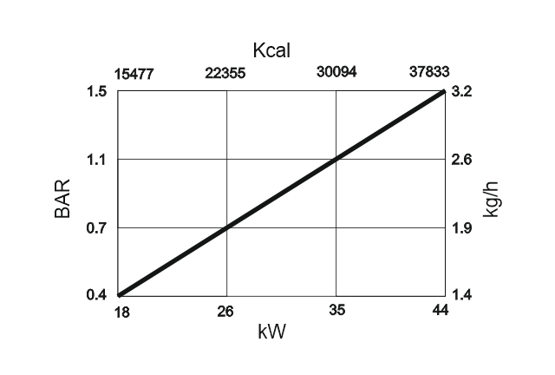
VII.1 ZONDA 45 :

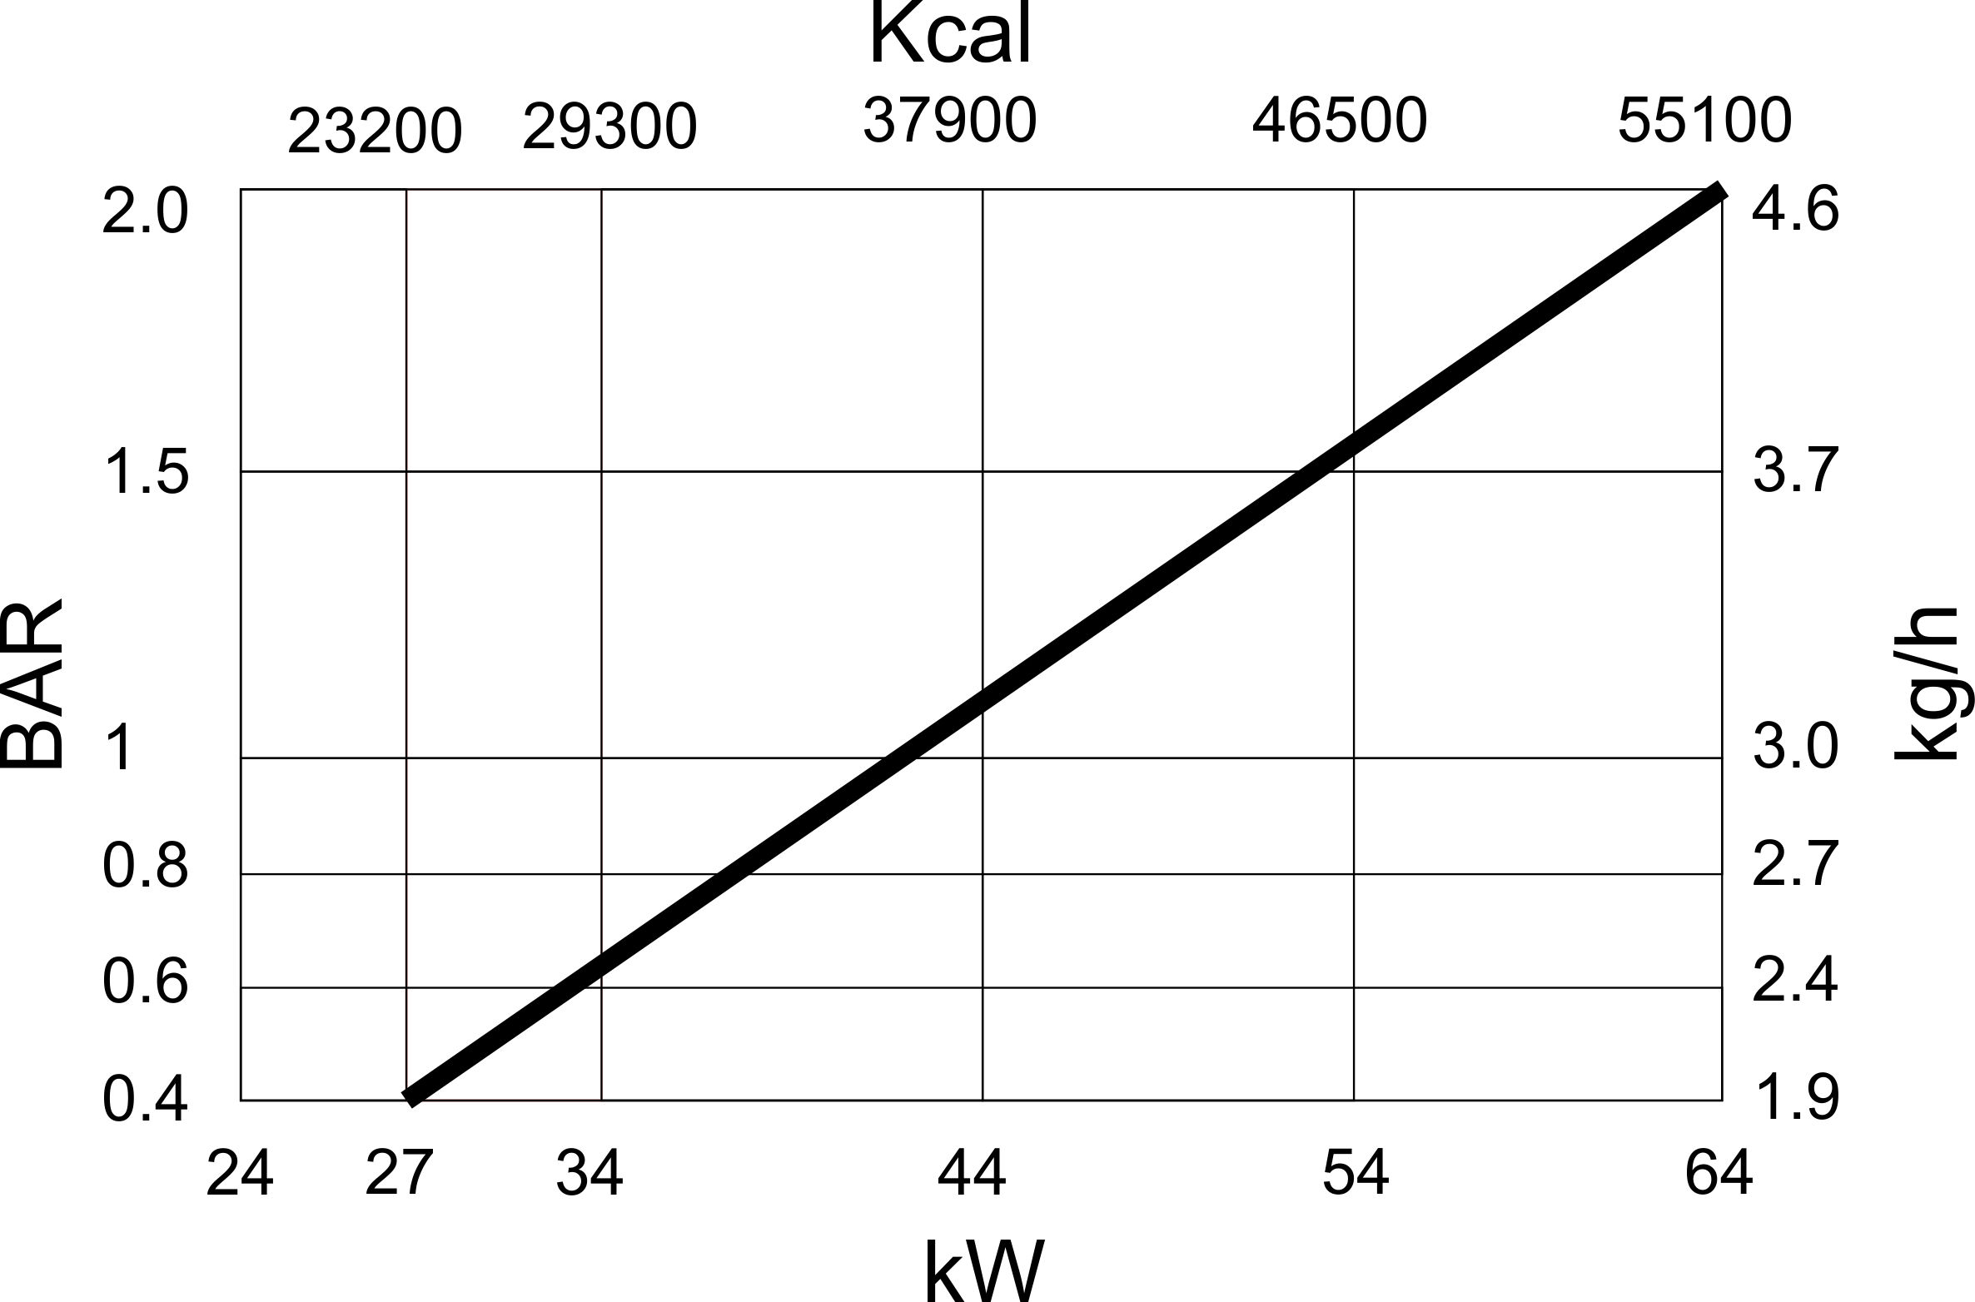VII.2 ZONDA 60 :

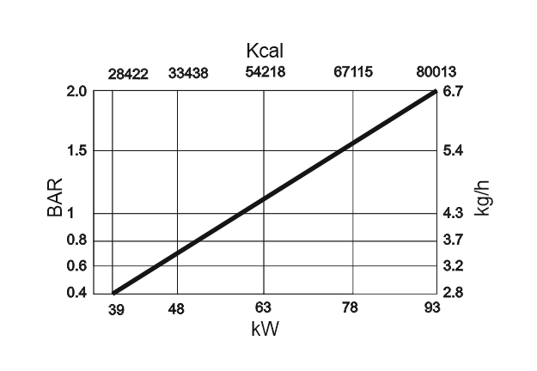
VII.3 ZONDA 90 :

VII.4 ZONDA 130 :
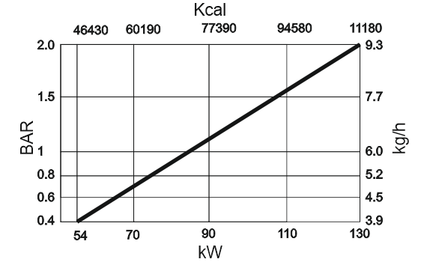

VIII – ELECTRICAL DIAGRAM FOR ZONDA 60/90/130

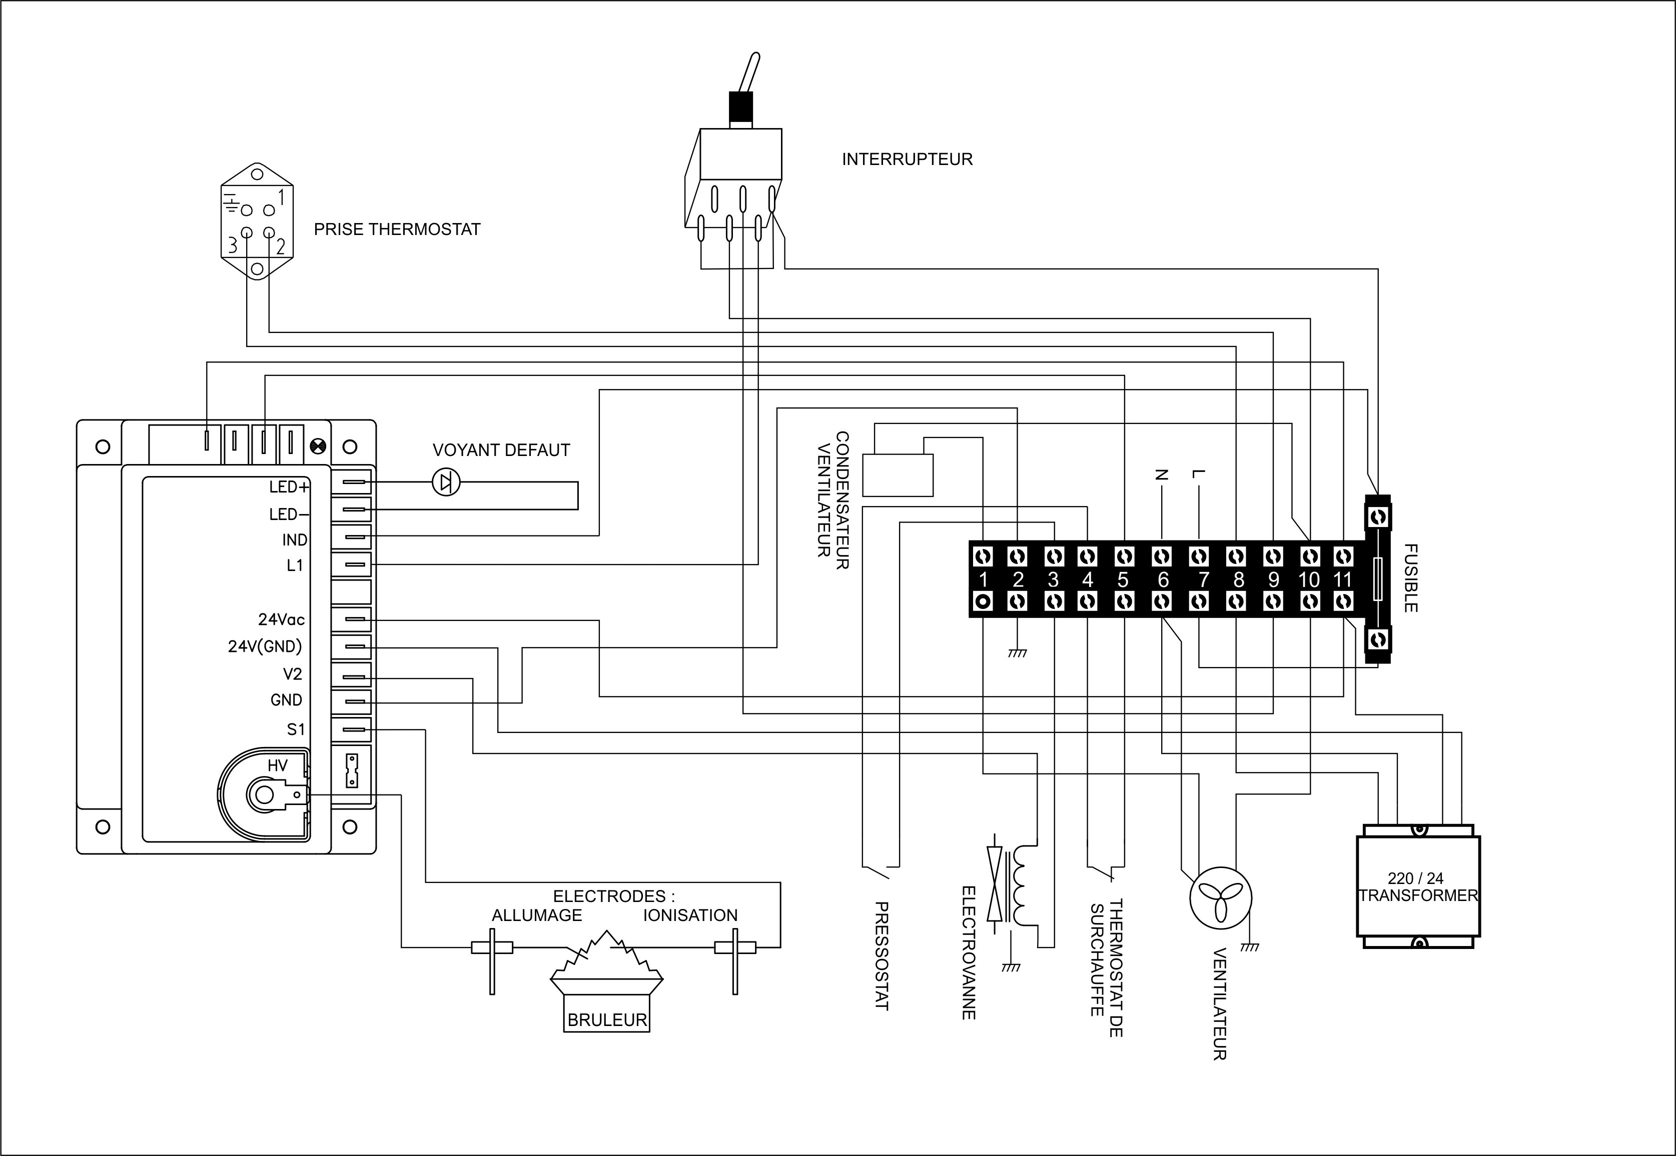
NOTES

---------------------------------------------------------------------------------------------------------------------------
---------------------------------------------------------------------------------------------------------------------------
---------------------------------------------------------------------------------------------------------------------------
---------------------------------------------------------------------------------------------------------------------------
---------------------------------------------------------------------------------------------------------------------------
---------------------------------------------------------------------------------------------------------------------------
---------------------------------------------------------------------------------------------------------------------------
---------------------------------------------------------------------------------------------------------------------------
---------------------------------------------------------------------------------------------------------------------------
---------------------------------------------------------------------------------------------------------------------------
---------------------------------------------------------------------------------------------------------------------------
---------------------------------------------------------------------------------------------------------------------------
---------------------------------------------------------------------------------------------------------------------------
---------------------------------------------------------------------------------------------------------------------------
---------------------------------------------------------------------------------------------------------------------------
---------------------------------------------------------------------------------------------------------------------------
---------------------------------------------------------------------------------------------------------------------------
---------------------------------------------------------------------------------------------------------------------------
---------------------------------------------------------------------------------------------------------------------------
---------------------------------------------------------------------------------------------------------------------------
---------------------------------------------------------------------------------------------------------------------------
MARLIS CONCEPT – 11 Rue Louis Lumière – 44980 St Luce sur Loire - FRANCE

