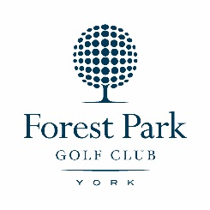
BAR MENU
LIGHT BITES
Soup of the Day £4.85

Toasted Teacake & Preserve £3.45

Bowl of Homemade Chips £ 4.15

Chip Buttie £4.90

Toasted Fruit Bread
1 slice £2.50
2 slices £3.60

Scrambled or 2 Poached £5.40
Eggs on Toast

Toasties from £6.05
Cheese with:
beans, tomato, onion, ham, tuna

Pasties, Pies & Sausage Rolls Available
BREAKFASTS
Birdie Breakfast £8.75
including tea/coffee

Eagle Breakfast £11.10
including tea/coffee

Breakfast Toasted Bap £8.10

Hot Butties from £4.75
Choose from:
egg, sausage, bacon, mushroom, tomato
or onion

Toast
(2 slices) Butter & Jam £2.95

COLD SANDWICHES
Farmhouse loaf served with a salad garnish, coleslaw and crisps

Cheddar Cheese or £5.35
Egg Mayonnaise

Corned Beef & Onion £5.60

Tuna Mayonnaise £5.60
and Cucumber

Prawn & Marie Rose Sauce or £6.30
Oven Roasted Ham

MAIN COURSES
2 Eggs & Chips £7.05

2 Sausages, 1 Egg & Chips £9.35

Cold Sliced Ham, £10.40
Egg & Chips

Scampi, Chips & Peas £11.30

PLEASE SEE SPECIALS BOARD

