   | Monday  Menu – Week One  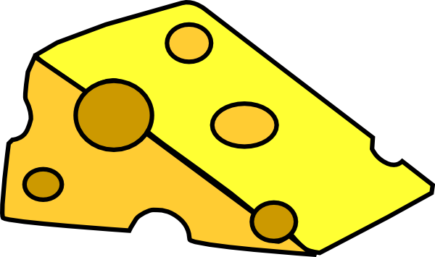 | Tuesday | Wednesday | Thursday   | Friday    
Breakfast  Planned to provide 20% of a child’s daily nutritional requirements | Selection of cereals, toast & dried fruit  (Wheat, Dairy)
Lunch & Pudding  Planned to provide 30% of a child’s daily nutritional requirements | Salmon & Broccoli potato bake  *Broccoli & Cheese bake  Custard & Fruit  Milk/Fish | Spaghetti Bolognese  (QUORN)  Cucumber  Fresh Fruit Salad  Wheat, Soya | Chicken & Vegetable Rice  *Vegetable rice  Pancakes & Fruit  Wheat | Cheese & vegetable pie  Yogurt  Milk | Chick pea & vegetable curry with rice  Ice-cream  Milk
Afternoon snack  Planned to provide 10% of a child’s daily nutritional requirements | Breadsticks/Fruit  Milk | Breadsticks/Fruit  Milk | Breadsticks/Fruit  Milk | Breadsticks/Fruit  Milk | Breadsticks/Fruit  Milk
Evening Tea & Pudding  Planned to provide 20% of a child’s daily nutritional requirements | Scrambled eggs & toast  Flapjack  Wheat/Egg | Tuna melt & Salad  Jelly  Fish, Wheat | Pasta Bake  Yogurt  Wheat/ Milk | Baked Beans & Toast  Apple tray bake  Wheat/Egg | Fish Finger wraps  Yogurt  Wheat/Fish/Milk
Note: Fresh drinking water is available and accessible at all times.


Red: Allergies V: Vegetarian Option

