Christingles
Christingle Services are organised to support the Children’s Society each year.
Over the last 50 years, Christingle celebrations have raised millions of pounds to support our life-changing work with children and young people. The money you raise can help connect them to our services, and rekindle the hope they deserve.

Background
It was first invented by the Moravian Church in the 1700s, and then a more recent version was introduced by the Children’s Society in the 1960s.
Last year, over 5,000 celebrations were held across the country raising over £1.2 million. The generosity and support shown at Christingle services is overwhelming and every year we are reminded of the compassionate Christinglers that help bring hope to young people across the country.
The Children’s Society runs vital services that provide vulnerable children across the country with the support, advice and guidance they need. They also campaign to make children’s lives better, and to change the systems that are placing them in danger.
How to make a Christingle
Christingles are homemade using oranges and other household items, as you choose. You light the candle at the end of the service to spread the light around everywhere.
Each element of a Christingle has a special meaning and helps to tell the Christian story.
- The orange represents the world
- The red ribbon or tape symbolises the love and blood of Christ
- The sweets or dried fruit represents all of God’s creation and provision
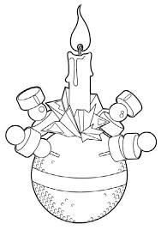
- The lit candle shows Christ’s light in the world, bringing hope to people living in darkness.
To Donate:
Please bring cash or cheques to Church on Sunday at 12 in an
envelope. Cheques made out to St Thomas PCC
Or if you prefer please pay in online banking to:
St Thomas Parochial Church Council
Sort Code 52-41-27
Account No 44086407
Reference: Children’s Society

