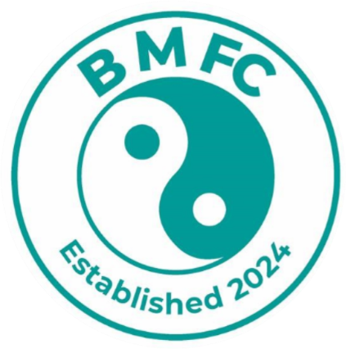

Balanced Minds FC Registration Form
This form will need to be completed on a Laptop/PC or by hand. In order to complete this form you will need to save a copy, complete the relevant fields and then re-save the form.

Balanced Minds FC Club Registration Number: Click or tap here to enter text. (Please use ‘2627’ then the first letter of your child’s first name and then your child’s surname as the reference for the payment, for example 2627NGodfrey.)
Child’s Details
First Name | Click or tap here to enter text.
Surname | Click or tap here to enter text.
Date of Birth | Click or tap to enter a date.
Address inc. postcode | Click or tap here to enter text.
Child’s FA Number (If known) | Click or tap here to enter text.
Parent/Carer 1 Details
First Name | Click or tap here to enter text.
Surname | Click or tap here to enter text.
Address inc. postcode | Click or tap here to enter text.
Relationship to child | Click or tap here to enter text.
Email Address | Click or tap here to enter text.
Contact Telephone Number | Click or tap here to enter text.

Parent/Carer 2 Details
First Name | Click or tap here to enter text.
Surname | Click or tap here to enter text.
Address inc. postcode | Click or tap here to enter text.
Relationship to child | Click or tap here to enter text.
Email Address | Click or tap here to enter text.
Contact Telephone Number | Click or tap here to enter text.
Medical Information
Any known medical conditions including Mental Health, ADHD, Allergies, Medication etc. | Click or tap here to enter text.
Emergency Contact 1 (Full Name) | Click or tap here to enter text.
Emergency Contact 1 (Telephone Number) | Click or tap here to enter text.
Emergency Contact 2 (Full Name) | Click or tap here to enter text.
Emergency Contact 2 (Telephone Number) | Click or tap here to enter text.

I hereby apply for membership registration to Balanced Minds FC on behalf of the above-named player for the coming season. By signing this form, I agree to abide by the BMFC and the Chiltern leagues Code of Conduct, copies of which are available on the club and league websites.
https://www.balancedmindsfc.com
Home | Chiltern Youth Football League

BALANCED MINDS FC, IT’S COMMITTEE MEMBERS, OFFICERS, REPRESENTATIVES OR VOLUNTEERS ARE UNDER NO LIABILITY WHATSOEVER FOR ANY LOSS OF PROPERTY, ACCIDENTS OR INJURIES HOWEVER CAUSED DURING TRAINING, MATCHES, BOTH TRAVEL TO AND FROM TRAINING OR MATCHES OR AT ANY EVENT ORGANISED BY THE CLUB. PLEASE NOTE THAT FINES FOR YELLOW/RED CARDS DURING GAMES ARE TO BE PAYABLE BY PARENTS/CARERS OF SAID PLAYER WITHIN 14 DAYS OF THE CLUB RECEIVING NOTIFICATION.

Please sign this and return this form to info@balancedmindsfc.com. If you are completing this form on your laptop/computer, you can sign the document by saving the document as a PDF document and then draw your signature on the document and then resave.
On signing this form, I and my parent/guardians understand and agree to follow Balanced Minds FC code of conducts.

Parent/Carer 1 Full Name (In Capitals): Click or tap here to enter text.
Parent/Carer 1 Signature:
Date:

Parent/Carer 1 Full Name (In Capitals): Click or tap here to enter text.
Parent/Carer 1 Signature:
Date:

Upon signing and returning this form to Balanced Minds FC, you are consenting for all information captured within this form to be captured and processed in line with our Privacy Policy, which is available here - Policies | Sports Mental Health Organization (balancedmindsfc.com)

Payment
All other age group Payment Information:
Upon completion of the club registration form, a non-refundable deposit of £50.00 is due to be paid to secure your child’s place at Balanced Minds FC. Please use ‘2627’ then the first letter of your child’s first name and then your child’s surname as the reference for the payment, for example 2627NGodfrey.
Please make this payment via bank transfer to:
Account Name: Balanced Minds FC
Account Number: 20984442
Sort Code: 20-05-73
Please note that the remaining amount of £100.00 is required to be paid in two separate payments, please see the split down below.
£50 Deposit - Due by 26th July 2026
£50 - Due by 26th August 2026
£50 – Due by 26th September 2026
The full amount of £150 can be paid in full, please note that cash payments are not accepted.
☐ Please tick this box to demonstrate that you understand the above statements. By ticking this box you are agreeing to the Club’s rules and acknowledging that payment is due.

