A PRACTICAL FAMILY GUIDE
The Seven-Day
Late-Afternoon
Pattern Tracker
A simple way to notice what changes across the day - and what may help Mum, Dad or another person you care about feel more settled later on.
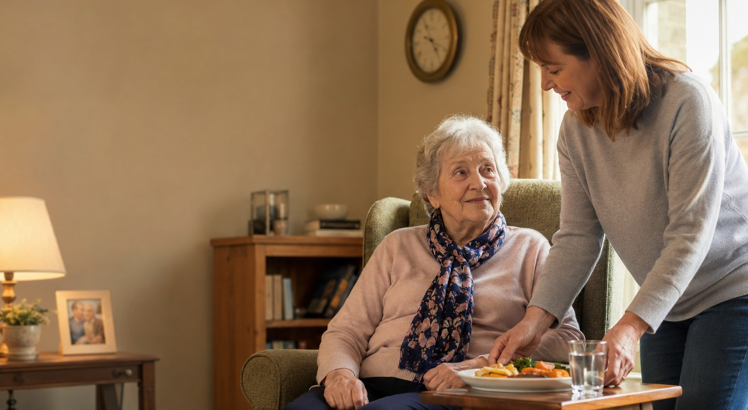
Use this alongside The 4pm Problem blog. If you notice a repeated pattern, take the completed tracker to a GP, pharmacist or other professional.

YOUR CARE
Thoughtful care from our family to yours

HOW TO USE THIS TRACKER
Look for the pattern, not a perfect record
An older person's ability can vary across a single day. Tiredness, missed food or drinks, medication timing, loneliness, pain and fading daylight can all affect how somebody feels and copes later on.
For seven days, write down what you know. Ask other relatives or support workers to add anything they notice. The most useful details are often the time something changed, what happened just beforehand, and what helped.
1 | Complete one page each day  Use ticks and short notes. If you are unsure, write 'unsure' rather than guessing.

2 | Pay attention to timing  Record when distress, confusion, low mood, tiredness or difficulty with everyday tasks begins.

3 | Review the week  Use the summary page to identify repeated triggers, better days and practical changes worth trying.

4 | Share it when useful  A GP, pharmacist or care professional may find the notes helpful when considering possible causes.

A change should never automatically be put down to age or dementia
Seek medical advice if the change is new, worsening or affecting safety. Sudden confusion can be linked to infection, dehydration, medication problems or another medical condition.
URGENT HELP: Call 999 for an immediate medical emergency. Use NHS 111 when urgent advice is needed but the situation is not life-threatening.

DAY 1  What happened today? | Date: ______________
Record what you know. Estimates are useful too - this does not need to be perfect.
Food | □ Breakfast | □ Lunch | □ Snack | □ Evening meal

Drinks | □ Very little | □ Some | □ Regularly | □ Unsure

What was eaten or drunk? Anything refused or forgotten?

Medication: what was taken and at what time? Any missed doses or changes?

Sleep / tiredness | □ Rested | □ Tired | □ Napped | □ Very sleepy

Mood later in the day | □ Settled | □ Anxious | □ Low | □ Irritable

What changed? Note the time and what you noticed.

Pain, constipation, urine changes, dizziness, illness or anything physically different?

Company, activity and surroundings: who visited, what happened, and were lights on before dusk?

What helped? Food, a drink, reassurance, brighter lighting, company, rest or something else?

DAY 2  What happened today? | Date: ______________
Record what you know. Estimates are useful too - this does not need to be perfect.
Food | □ Breakfast | □ Lunch | □ Snack | □ Evening meal

Drinks | □ Very little | □ Some | □ Regularly | □ Unsure

What was eaten or drunk? Anything refused or forgotten?

Medication: what was taken and at what time? Any missed doses or changes?

Sleep / tiredness | □ Rested | □ Tired | □ Napped | □ Very sleepy

Mood later in the day | □ Settled | □ Anxious | □ Low | □ Irritable

What changed? Note the time and what you noticed.

Pain, constipation, urine changes, dizziness, illness or anything physically different?

Company, activity and surroundings: who visited, what happened, and were lights on before dusk?

What helped? Food, a drink, reassurance, brighter lighting, company, rest or something else?

DAY 3  What happened today? | Date: ______________
Record what you know. Estimates are useful too - this does not need to be perfect.
Food | □ Breakfast | □ Lunch | □ Snack | □ Evening meal

Drinks | □ Very little | □ Some | □ Regularly | □ Unsure

What was eaten or drunk? Anything refused or forgotten?

Medication: what was taken and at what time? Any missed doses or changes?

Sleep / tiredness | □ Rested | □ Tired | □ Napped | □ Very sleepy

Mood later in the day | □ Settled | □ Anxious | □ Low | □ Irritable

What changed? Note the time and what you noticed.

Pain, constipation, urine changes, dizziness, illness or anything physically different?

Company, activity and surroundings: who visited, what happened, and were lights on before dusk?

What helped? Food, a drink, reassurance, brighter lighting, company, rest or something else?

DAY 4  What happened today? | Date: ______________
Record what you know. Estimates are useful too - this does not need to be perfect.
Food | □ Breakfast | □ Lunch | □ Snack | □ Evening meal

Drinks | □ Very little | □ Some | □ Regularly | □ Unsure

What was eaten or drunk? Anything refused or forgotten?

Medication: what was taken and at what time? Any missed doses or changes?

Sleep / tiredness | □ Rested | □ Tired | □ Napped | □ Very sleepy

Mood later in the day | □ Settled | □ Anxious | □ Low | □ Irritable

What changed? Note the time and what you noticed.

Pain, constipation, urine changes, dizziness, illness or anything physically different?

Company, activity and surroundings: who visited, what happened, and were lights on before dusk?

What helped? Food, a drink, reassurance, brighter lighting, company, rest or something else?

DAY 5  What happened today? | Date: ______________
Record what you know. Estimates are useful too - this does not need to be perfect.
Food | □ Breakfast | □ Lunch | □ Snack | □ Evening meal

Drinks | □ Very little | □ Some | □ Regularly | □ Unsure

What was eaten or drunk? Anything refused or forgotten?

Medication: what was taken and at what time? Any missed doses or changes?

Sleep / tiredness | □ Rested | □ Tired | □ Napped | □ Very sleepy

Mood later in the day | □ Settled | □ Anxious | □ Low | □ Irritable

What changed? Note the time and what you noticed.

Pain, constipation, urine changes, dizziness, illness or anything physically different?

Company, activity and surroundings: who visited, what happened, and were lights on before dusk?

What helped? Food, a drink, reassurance, brighter lighting, company, rest or something else?

DAY 6  What happened today? | Date: ______________
Record what you know. Estimates are useful too - this does not need to be perfect.
Food | □ Breakfast | □ Lunch | □ Snack | □ Evening meal

Drinks | □ Very little | □ Some | □ Regularly | □ Unsure

What was eaten or drunk? Anything refused or forgotten?

Medication: what was taken and at what time? Any missed doses or changes?

Sleep / tiredness | □ Rested | □ Tired | □ Napped | □ Very sleepy

Mood later in the day | □ Settled | □ Anxious | □ Low | □ Irritable

What changed? Note the time and what you noticed.

Pain, constipation, urine changes, dizziness, illness or anything physically different?

Company, activity and surroundings: who visited, what happened, and were lights on before dusk?

What helped? Food, a drink, reassurance, brighter lighting, company, rest or something else?

DAY 7  What happened today? | Date: ______________
Record what you know. Estimates are useful too - this does not need to be perfect.
Food | □ Breakfast | □ Lunch | □ Snack | □ Evening meal

Drinks | □ Very little | □ Some | □ Regularly | □ Unsure

What was eaten or drunk? Anything refused or forgotten?

Medication: what was taken and at what time? Any missed doses or changes?

Sleep / tiredness | □ Rested | □ Tired | □ Napped | □ Very sleepy

Mood later in the day | □ Settled | □ Anxious | □ Low | □ Irritable

What changed? Note the time and what you noticed.

Pain, constipation, urine changes, dizziness, illness or anything physically different?

Company, activity and surroundings: who visited, what happened, and were lights on before dusk?

What helped? Food, a drink, reassurance, brighter lighting, company, rest or something else?

AFTER SEVEN DAYS
What pattern can you see?
Do not worry if there is no single obvious answer. A few repeated details can still show where to begin.
What time did the difficult period usually begin?

Which signs appeared more than once?

Were food or drinks missed, delayed or refused on the harder days?

Did anything seem linked to medication timing, sleep, pain or illness?

Was the person alone, less active, or in a darker room before the change?

What helped most consistently?

What would you like to ask a GP, pharmacist or care professional?

WHAT TO TRY NEXT
Plan support around the hardest hours
The aim is not to take over. It is to make the difficult part of the day safer, calmer and less lonely.
Food and fluids | Make lunch and drinks visible and easy to reach. Consider a planned snack or drink before the usual difficult period.

Lighting | Switch lamps on before the room becomes dim. Close curtains as daylight fades and reduce confusing shadows or reflections.

Routine | Keep demanding tasks earlier in the day. Add a familiar activity, call or visit before the usual change begins.

Medication | Do not change medication or timing without advice. Ask a GP or pharmacist if a repeated pattern appears linked to a dose.

Well-timed support | A familiar person visiting at the right time can prepare food, encourage drinks, give medication prompts, notice changes and help settle the evening routine.

Talk it through with Your Care
If Mum or Dad seems fine in the morning but regularly struggles later, a support visit timed around the difficult hours may make more difference than a visit earlier in the day.
Call 0117 947 7422
Home support across Bristol, South Gloucestershire and BANES
This tracker is for observation and discussion. It does not diagnose a condition or replace medical advice.

