

Ulm-Messe GmbH - Böfinger Str. 50, 89073 Ulm, Germany

EXHIBITOR SERVICES MANUAL

Stay connected:

#MedicaltechDE

1. EVENT TIMETABLE 3
1-1 Build Up 3
1-2 Exhibition Open Period 3
1-3 Breakdown 3
1-4 Car Parking and access. 3-4
2. EVENT CONTACTS 5
2-1 Event Management & Sales Enquiries 5
2-2 Marketing & Public Relations 5
2-3 Conference Content 5
2-4 Stand Build, Operations & Technical Management 5
2-5 Show Preview and Show Guide 5
2-6 Official Contractors 5-6
3. A-Z INFORMATION 7
3-1 Exhibitor Badges & Passes 7
3-2 Canvassing 7
3-3 Show Planners & Show Preview 7
3-4 Deliveries 7
3-5 First Aid 7
3-6 Gangways 8
3-7 Insurance 8
3-8 Maintenance & Repair 8
3-9 Removal of Exhibits 8
3-10 Security 8
3-11 Children and animals 8
4. SAFETY & SECURITY 9
4-1 Shell Scheme 9
4-2 Security 9
4-3 Venue Emergency & Fire Procedures 9
OTHER FORMS 10
Lead Retrieval Device Order Form 10
Simple Risk Assessment 11-14

1. EVENT TIMETABLE

1-1 Build Up
Tuesday 30 June 2026
14.00-19.00hrs
Note: All exhibits MUST be set up by 1900hrs on Tuesday 30 June.
All gangways must be kept clear of all exhibits, packaging and stand fitting materials, at all times, to comply with Health & Safety and to assist the cleaners. Penalties for non-compliance may be incurred.

1-2 Exhibition Open Period
Wednesday 1 July 2026
09.30-16:30hrs
Thursday 2 July 2026
09.30-15:30hrs (last admission 15:00hrs)
Exhibitor access from 08.00hrs each morning.

1-3 Breakdown
1-4 Car Parking and Access 1
Thursday 2 July 2026
15:30-19.00hrs
All exhibits MUST be cleared by 19.00hrs on Thursday 2 July.
It is a contractual requirement that your stand is not dismantled in any way, or product removed and remains staffed until the show closes.
Contractors will only be granted access to the halls once it is clear of all visitors.
Exhibitors are advised not to leave their stand unattended at any time during breakdown.
It is the exhibitor’s responsibility to remove all stand materials, carpet tape, packaging, and waste from the halls. Please note that charges will be levied for the removal of any discarded items.

1-4 Car Parking and access.
FREE parking is provided for all exhibitors at the rear of the Messe.
Parking for larger vehicles is also provided with direct access to the exhibition hall.
Vehicles may be left in the allocated area for the duration of the event.

Ulm-Messe GmbH - Böfinger Str. 50, 89073 Ulm, Germany
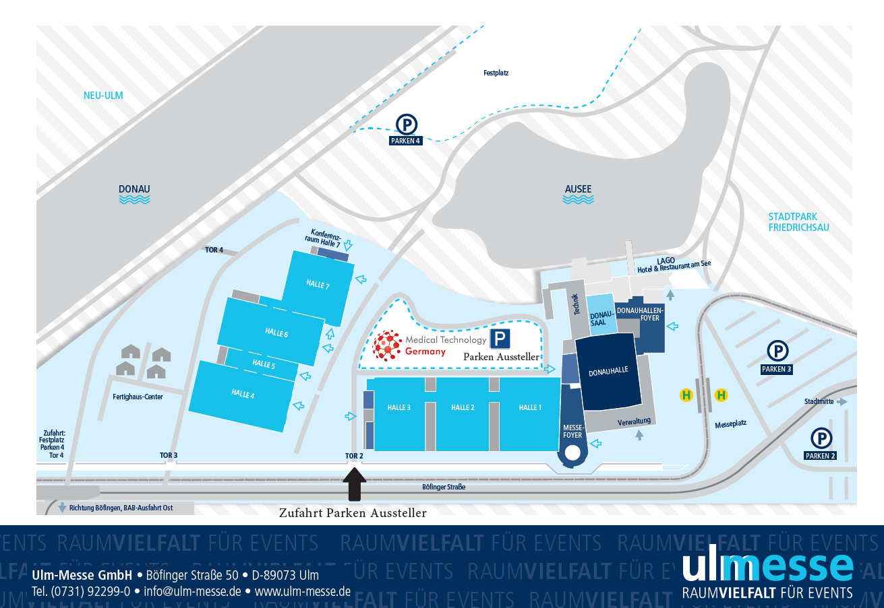

2. EVENT CONTACTS

2-1 Event Management & Sales Enquiries
Guido Kuepper - Event Director
Email: guido.kuepper@medicaltechnologygermany.com
Tel: +49 (0) 177 787 1007

2-2 Marketing & Public Relations
Colin Martin – Event Director
Email: colin.martin@medicaltechnologyuk.com
Sara Williams – Marketing Director
Email: sara@medicaltechnologygermany.com

2-3 Conference Content
Guido Kuepper - Event Director
Email: guido.kuepper@medicaltechnologygermany.com
Tel: +49 (0) 177 787 1007

2-4 Stand Build, Operations & Technical Management
Jennifer Walsh - Total Expo Ltd
Email: info@totalexpo.ie
Tel: +353 (0) 1 413 7315 or +353 (0) 1 413 7371
Exhibition Stand Orders: Total Expo Limited – ONLINE SHOP

2-5 Show Preview and Show Guide
Joachim Linckh - Email: joachim.linckh@konradin.de
If you wish to advertise in the Show Preview or Show Guide by medizing&technik

2-6 Official Contractors

Audio Visual
Jennifer Walsh, Cormac, and Michelle - Total Expo Ltd
Email: info@totalexpo.ie
Tel: +353 (0) 1 413 7315 or +353 (0) 1 413 7371
Exhibition Stand Orders: Total Expo Limited – ONLINE SHOP

Exhibitor badges & visitor data capture
Exhibitor badges can be ordered online HERE
They may be collected at the Registration Desk from 14.00 on 30 June.
They will not be emailed prior to the event.

The Visitor Data App must be ordered in advance HERE.

Logistics & Shipping
CEVA SHOWFREIGHT will deliver the goods directly to your stand at an agreed date / time and remove any packing cases, storing them until the show closes. CEVA will collect your shipment after the event and transport back to the place of origin. If you require any help / advice about shipping to Medical Technology Germany, please contact:
Email: Cameron.setaro@cevalogistics.com
Tel: +44 (0) 121 782 8888

Stand builder, Electrics, Furniture, & Graphics
Jennifer Walsh - Total Expo Ltd
Email: info@totalexpo.ie
Tel: +353 (0) 1 413 7315 or +353 (0) 1 413 7371
Exhibition Stand Orders: Total Expo Limited – ONLINE SHOP

3. A-Z INFORMATION

3-1 Exhibitor Badges & Passes
Register all staff needing badges in advance. These badges must be worn on-site at all times during the open period of the exhibition. They may be collected at the Registration Desk from 14.00 on 30 June and will NOT be emailed prior to the event.
Exhibitor badges can be ordered online HERE

3-2 Canvassing
Exhibitors may only conduct business and distribute literature from within the boundaries of their own stands. Under no circumstances may activities spill into gangways – this includes the use of promotional staff or characters. If you are approached on your stand, by unwelcome visitors trying to sell their products, please take a business card and inform the Organiser’s Office immediately so that appropriate action can be taken.
All exhibitors are advised that unless they have a contractual agreement with the event organisers, all promotional activity is restricted to the limits of their stand. For details of opportunities available in the halls, please contact the Event Director: guido.kuepper@medicaltechnologygermany.com

3-3 Show Planners & Show Preview
Available at the entrance and registration area.

3-4 Deliveries
Please note that neither the Organiser nor the Venue can accept responsibility for items that require a signature – you must ensure that there is someone available on your stand to receive such items. Deliveries can only be made during the official build-up and open period. Please note that many courier companies do not deliver on weekends.
The unloading and placing of exhibits on stands are the exhibitor’s own responsibility. Our official lifting contractor, CEVA Logistics, is experienced in exhibition work and will be pleased to help with any queries regarding handling.
PLEASE NOTE THAT THE VENUE WILL NOT ACCEPT ANY DELIVERIES MADE PRIOR TO THE START OF TENANCY. Please ensure that you advise your couriers to deliver when you are on-site and available to accept and sign for them yourself.

3-5 First Aid
Located at the venue Registration Desk.

3-6 Gangways
There will be no off-loading of exhibits or stand fitting materials into the gangways under any circumstances.
Emergency gangways MUST be kept clear at all times and anything left in any gangway will be deemed as rubbish by the cleaners and removed. Gangways must be kept completely clear at all times.

3-7 Insurance
Mandatory for all exhibitors to hold public liability insurance. You must provide a copy of your insurance policy and be insured for Public Liability to a minimum level of £2,000,000 or €2,500,000 or $3,000,000.
Any loss or damage that may occur during the show should immediately be notified to the Organisers and Security on-site. Please note that Exhibitor Contracts do not cover stand contractors and any subsequent sub-contractors, and as such contractors are now required to submit proof that they have adequate insurance cover.

3-8 Maintenance & Repair
Maintenance work is allowed before or after show hours only. No maintenance will be permitted during the opening hours.

3-9 Removal of Exhibits
Exhibitors are reminded that product may not be taken out of the show before the show closes. All visitors leaving the building with product must have the correct documentation for this.

3-10 Security
Security staff patrol overnight; however, exhibitors must take precautions.
Any incidents of theft must be reported to the Organisers immediately as it will be necessary to report the incident to the police.
Please note that most hired cabinets have common locks and should NOT be regarded as secure units.
Please note that neither the Organisers nor the venue can be held responsible for any loss or damage to stands or exhibits.

3-11 Children and animals
Under no circumstances are children of 16 years and under or animals (except service animals) allowed inside the venue at any time during the buildup, open period, or breakdown.

4. SAFETY & SECURITY

4-1 Shell Scheme
Shell Scheme exhibitors need to identify the hazards present on-site and ways in which you will minimise and control these risks.
Please complete a Risk Assessment Form provided at the back of this manual

4-2 Security
Regularly check your stand for suspicious items.

4-3 Venue Emergency & Fire Procedures
If in the unlikely event of an emergency, please vacate the Halls via the nearest exit, using the staircases and not the lifts, and gather in the car park.

Fraud Alert
Medical Technology Germany, Medical Technology UK, and Medical Technology Ireland DO NOT rent or sell their visitor or exhibitor data. Anyone purporting to sell such data is fraud!
Please DO NOT respond to any solicitations in relation to "list rental" for any of our events.
Exhibitor Networking Drinks Reception
Exhibitor networking drinks are on 9 July at the Maritim Hotel - Ulm
5.00pm – 7.00pm.
All exhibitors and their teams are welcome.

OTHER FORMS

Lead Retrieval Device Online Order Form

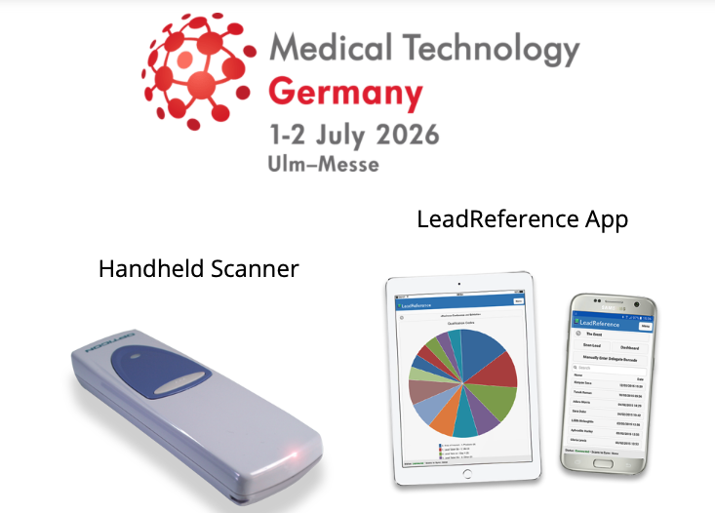


SIMPLE RISK ASSESSMENT

RISK ASSESSMENT FOR SIMPLE EXHIBITION STANDS

Stand Name: | Name of person responsible for Health & Safety:
Stand Number: | Work No:  Mobile No: E-mail

Exhibitor's Responsibilities
An exhibition stand is a workplace covered by Health and Safety legislation. As the exhibitor, it is your responsibility to ensure that a suitable and sufficient risk assessment is completed. Failure to do so could lead to delays or the closure of your stand.
The template is for a simple shell scheme exhibition stand which does not require any structural approval from the organiser or the venue. More complex stands will require a more detailed risk assessment, and if you are in doubt, you should contact the organiser.
Does your stand include any of the following? If so, you must complete the attached risk assessment for simple stands:

Yes/No
Display of anything containing liquid fuel e.g., a motor vehicle
Display of sharp objects, weapons (even replica weapons)
Demonstrations of any kind
Working electrical appliances other than simple display lighting
Food Service of any kind other than sweets, snacks, and soft drinks
Heat source of any kind including cookery demonstrations, naked flame, or gel burners
Pressurised gases
Working machinery of any kind even if static
Laser demonstration
Any other hazard not identified above which could be a risk

Note this is not an exhaustive list. You are responsible for identifying any aspect of your stand which could present a hazard.
If you have answered NO to all of the above, please sign below. If you have answered YES to any of the above, please complete the risk assessment attached.
I declare that to the best of my knowledge there are no significant risks relating to this stand

Signed: | Name: | Date:

SIMPLE RISK ASSESSMENT

RISK ASSESSMENT FOR SIMPLE EXHIBITION STANDS

Stand Number: | Exhibitor Name

Risk:
Who could be harmed?
Control Measures in Place:

To the best of my knowledge, the information provided is correct. The control measures in place control risk to an acceptable degree.

Signed: | Name: | Date:

